Cecil Andrews College

Y11 PHYSICS

**HEATING FUNDAMENTALS  
TEST – 2023**

Student Name: ________________________

41

**Time**: 1 Hour

**NOTE:**

1. Calculations must show **clear working** with **formulae.**
2. State your final answers to **three significant figures.**
3. Marks may be allocated for clear and logical setting out
4. State assumptions if working on open ended type questions.
5. Write a brief statement (with reference to energy transfer) to explain each of the following observations. (**2** marks each)

|  |
| --- |
| 1. The temperature inside a black car initially increases at a higher rate than the temperature inside a white car when left standing in the sun.   ________________________________________________________________________________  ________________________________________________________________________________  ________________________________________________________________________________  ________________________________________________________________________________  ________________________________________________________________________________  ________________________________________________________________________________  ________________________________________________________________________________  ________________________________________________________________________________ |
| b) Inland daytime temperatures are usually higher than those at places near the coast.  ________________________________________________________________________________  ________________________________________________________________________________  ________________________________________________________________________________  ________________________________________________________________________________  ________________________________________________________________________________  ________________________________________________________________________________  ________________________________________________________________________________  ________________________________________________________________________________ |
| c) In winter time, walking bare-footed across a tiled floor feels much colder than walking on a carpeted floor  ________________________________________________________________________________  ________________________________________________________________________________  ________________________________________________________________________________  ________________________________________________________________________________  ________________________________________________________________________________  ________________________________________________________________________________  ________________________________________________________________________________  ________________________________________________________________________________ |
| d) Using a damp cloth to remove a hot container from an oven may result in severe burns.  ________________________________________________________________________________  ________________________________________________________________________________  ________________________________________________________________________________  ________________________________________________________________________________  ________________________________________________________________________________  ________________________________________________________________________________  ________________________________________________________________________________  ________________________________________________________________________________ |

1. You have been given a thermometer with a numbered graduated scale. Without using another known instrument for measuring temperature, explain how you would scientifically verify that the thermometer scale is in Celsius?  
   Answer the question in point form. **(2 marks)**
2. For the following statements (1) to (4), select the option (A, B, C, D or E) which best describes its association with a method of heat transfer. **(2 marks)**

|  |  |
| --- | --- |
| OPTIONS | |
| A | Convection currents |
| B | Expansion of solids |
| C | Radiation |
| D | Conduction |
| E | Expansion of liquids |

|  |  |  |
| --- | --- | --- |
| STATEMENTS | | Selected option |
| 1 | Hot air balloons. |  |
| 2 | Operation of a mercury-in-glass thermometer. |  |
| 3 | The bases of frying pans are sometimes made of copper. |  |
| 4 | An aluminium window frame feels cold when you touch it on a cold day. |  |

1. A 65.0 g pellet of Noohopium metal is heated to 135ºC and is quickly placed into a 120 g glass beaker containing 320 g of water at a temperature of 25.0ºC. The final maximum equilibrium temperature is 30.9ºC (assume no heat loss). Specific heat of glass = 0.84 x 103 J kg-1 K-1.  
   Determine the specific heat of the Noohopium metal. **(4 marks)**
2. In making iced tea 1.75 kilograms of hot tea at 100ºC is cooled to 0.0ºC using a quantity of ice at 0.0 ºC. (The specific heat of ice tea = 4.18 x 103 J kg-1 K-1)

**(a)** Show your work to determine whether or not 2.00 kilograms of ice added to the hot tea will achieve a final temperature of 0.0ºC. **(3 marks)**

**(b)** What is the final temperature achieved with adding 2 kilograms of ice? **(3 marks)**

**(c)** How much ice is required for the iced tea to achieve 0.0ºC? **(2 marks)**

1. The diagram below shows a graph of temperature against time for a particular substance that has a mass of 0.2 kg which has been cooled at a constant rate of 2000J each second from a high temperature to a low temperature. Use the letters to answer the following questions and explain your answers. **(5 marks)**

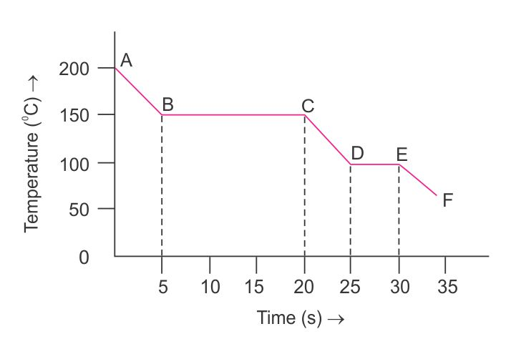

|  |  |  |  |
| --- | --- | --- | --- |
| **Question** | | **Answer** | mk |
| (a) | At which point is the substance completely solid. |  | **½** |
| (b) | Which section, or sections, of the graph show the substance in two states at the same time. |  | **½** |
| Explain your answer. | | **1** |
| (c) | Which section of the graph shows the liquid phase? |  | **½** |
| Determine the specific heat of the liquid phase. | | **1** |
| (d) | At which point do the molecules of the substance have the largest average Kinetic Energy? |  | **½** |
| Explain your answer. | | **1** |

1. Solar hot water systems convert electromagnetic energy from the sun to thermal energy in the water in the heater. How much solar energy does a solar heater need to absorb to raise the temperature of 165 kg of water from 22.0 °C to 85.0 °C? Assume that the system converts only 70% the solar energy to thermal energy of the water. (3 marks)
2. On Master Chef a competitor pours 920g of soup at 95.0 °C into a 120g china bowl with a specific heat capacity of 1085 Jkg-1K-1. The soup raises the temperature of the china bowl from 22.0 °C to 82.0 °C. Determine the specific heat capacity of the soup. (3 marks)
3. The diagram to the right shows a cross section of a thermos flask. Explain the purpose of the three heat concept characteristics listed below in the design of these thermos flasks. (6 marks)

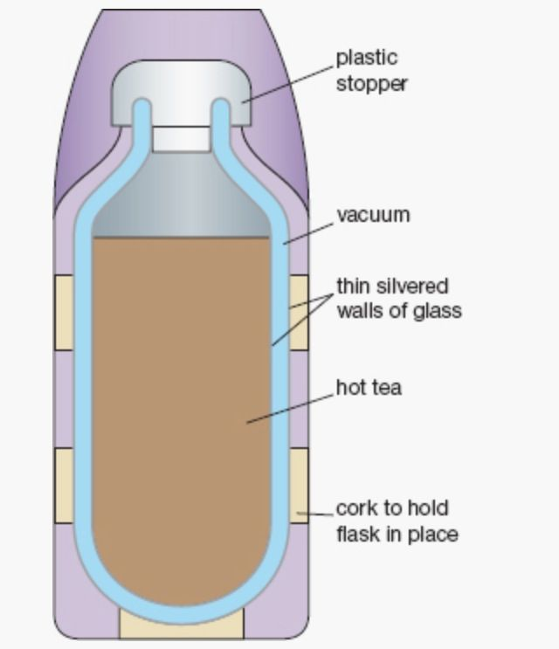

|  |
| --- |
| Vacuum: |
| Thin silvered walls of glass: |
| Cork to hold the flask in place: |

|  |
| --- |
| ☺ CONGRATULATIONS: ☺ YOU HAVE COMPLETED THE 1st Y11 PHYSICS TEST |